|  |
| --- |
| **JDN Standards – Upgrade vSphere 5.5 to 6.5** |

Introduction 2

Prerequisites 2

Upgrade your vCenter Server Appliance 3

Upgrade the ESXi hosts 19

Upgrade VMs 27

Upgrade DC to Windows Server 2016 29

Upgrade Server VMs to Windows Server 2016 35

Create new Win 10 Clients VM’s 37

Raise FFL and DFL 38

Upgrade Applications 41

Commbox 41

Pihole 41

Licensing 41

Troubleshooting 43

iCat doesn’t work 43

Veeam 43

iRep doesn’t work 43

Dell Storage Driver Error bij upgrade Windows Server OS of the task server 44

Win10 Jump 46

UPS 47

Wifi 47

WR44 47

Radio holland 47

Printers 47

Outlook 47

Excel 47

# Introduction

This document describes the process of upgrading a vSphere environment from version 5.5 to 6.5 (according to the current standards version).

# Prerequisites

The following software was used to accomplish the migration:

* vCenter Upgrade:
  + **VMware-VCSA-all-6.5.0-8024368.iso**
* ESXi Upgrade:
  + **VMware-VMvisor-Installer-6.5.0.update01-7967591.x86_64-DellEMC_Customized-A10.iso**
* Windows Server 2016:
  + **SW_DVD9_Win_Server_STD_CORE_2016_64Bit_English_-4_DC_STD_MLF_X21-70526**
* Windows 10:
  + **SW_DVD9_Win_Pro_Ent_Edu_N_10_1809_64-bit_English_MLF_X21-96501**

Rerun all backup jobs in your Veeam installation.

# Upgrade your vCenter Server Appliance

Mount your vCenter Server Appliance ISO image, and navigate to the vcsa-ui-installer folder where you will find the installer which will guide you through the upgrade process of vCenter. Run this with elevated rights as shown below:

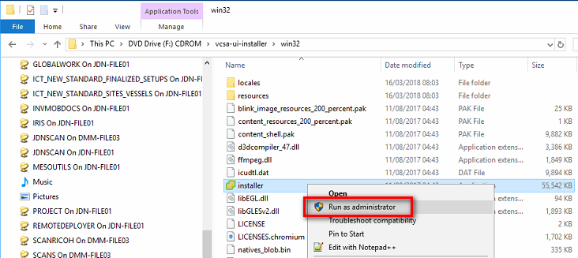

Once the vCenter Server Appliance 6.5 Installer opens, choose Upgrade:

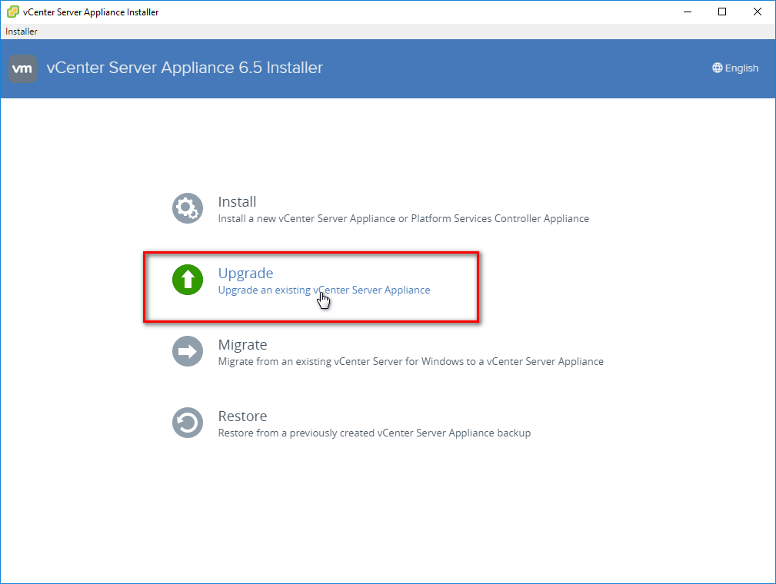

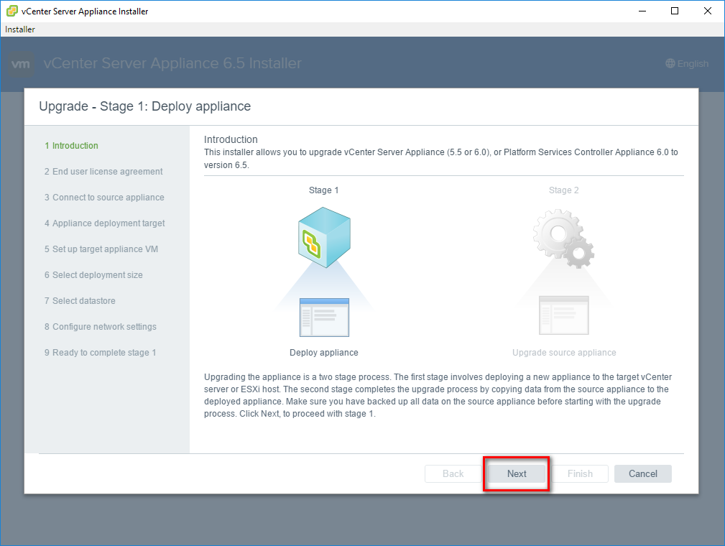

Accept the EULA

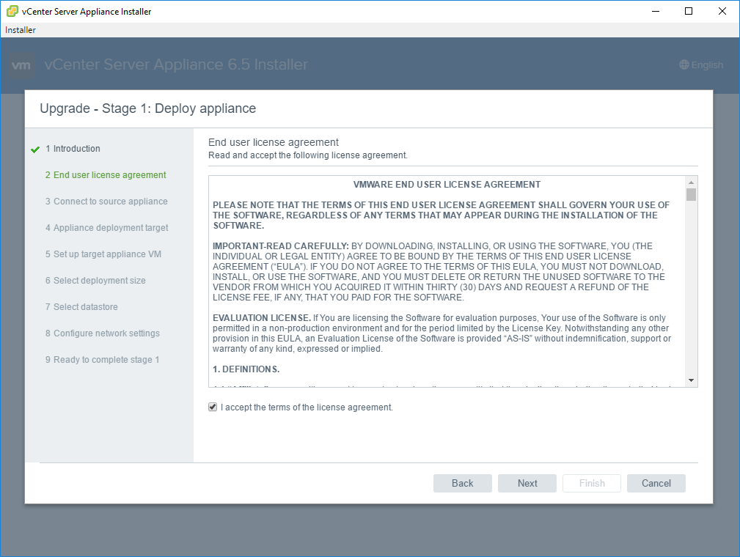

Fill in the vCenter IP address and click connect to Source to verify connection

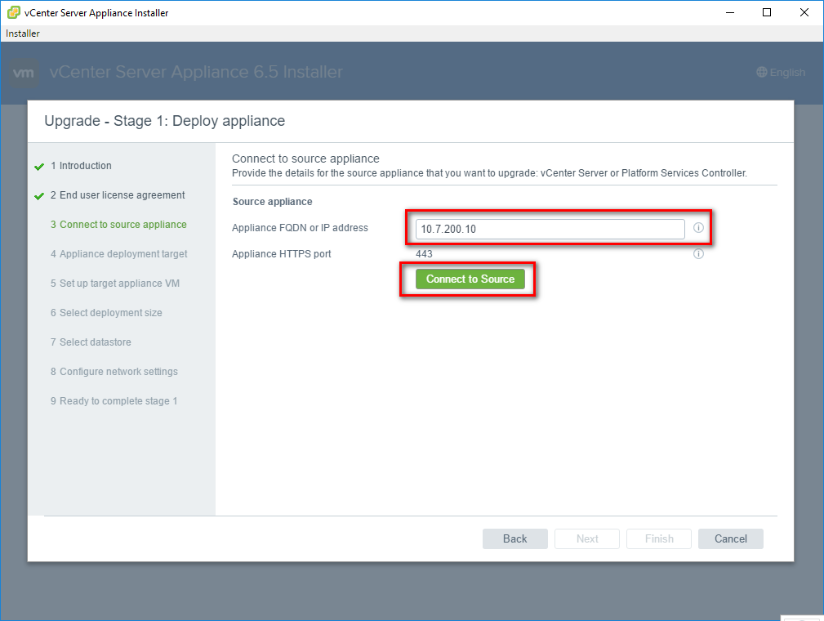

Fill in the remaining info.

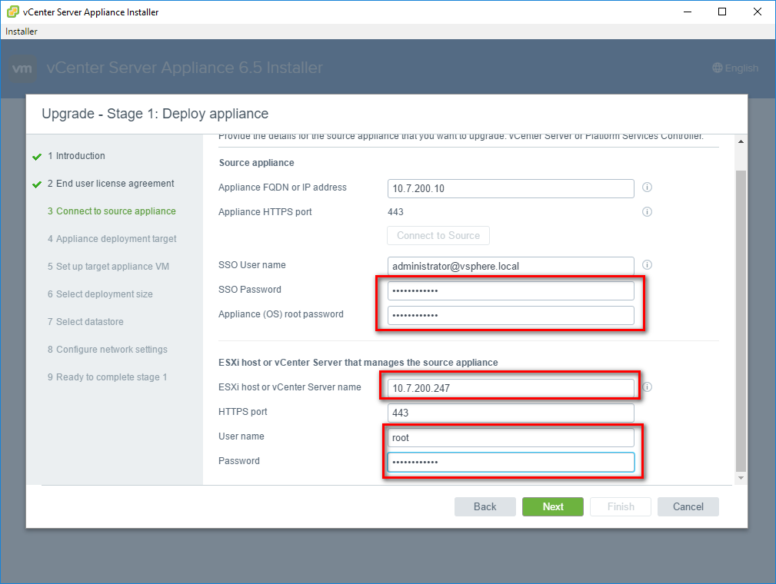

If login fails check if you can login to the vcenter management web page (Vcenterip: 5480)

If this also fails then the password is expired and needs to be reset using the following procedure: <https://kb.vmware.com/s/article/2069041>

At the Certificate Warning prompt, press yes.

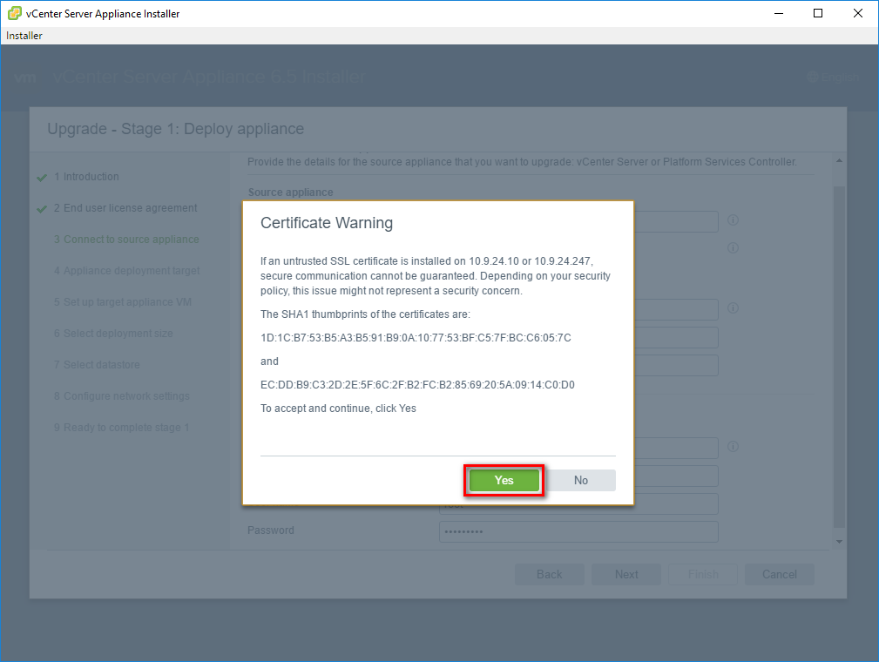

Because our standards don’t use an External PSC, choose Embedded Platform Services Controller.

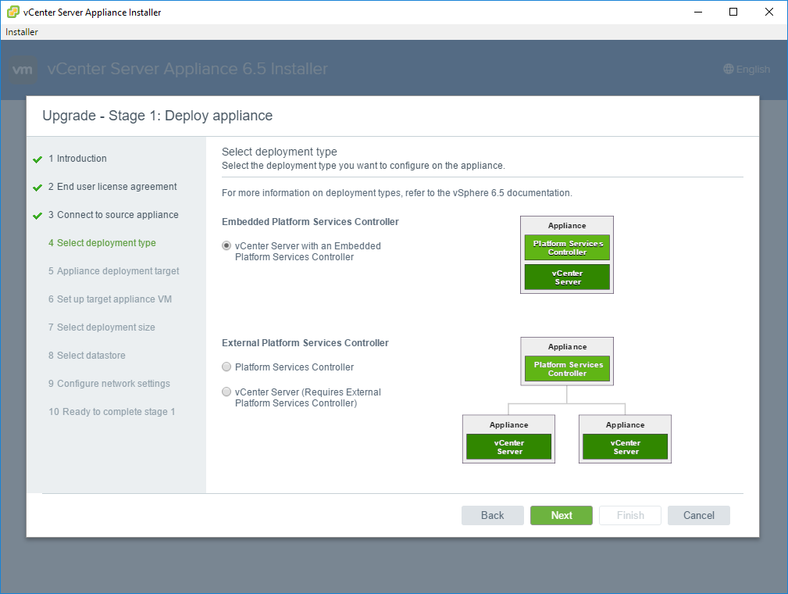

Specify the ESXi host information on which the new vCenter Server will be deployed

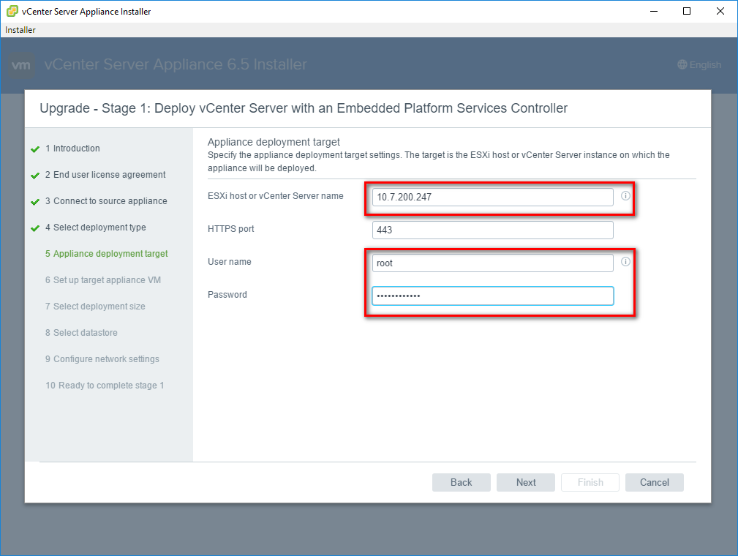

At the Certificate Warning again press Yes

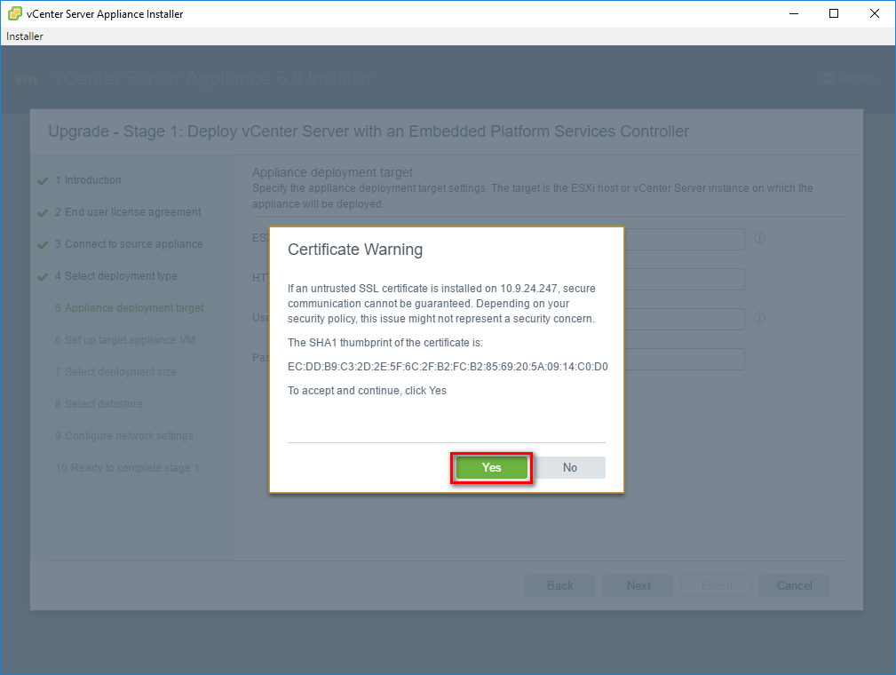

Enter the information for the new vCenter Server. As there is already a vCenter Server in your environment named as XX-VCENTER01, you will have to choose here XX-VCENTER02. Later on we will configure an alias.

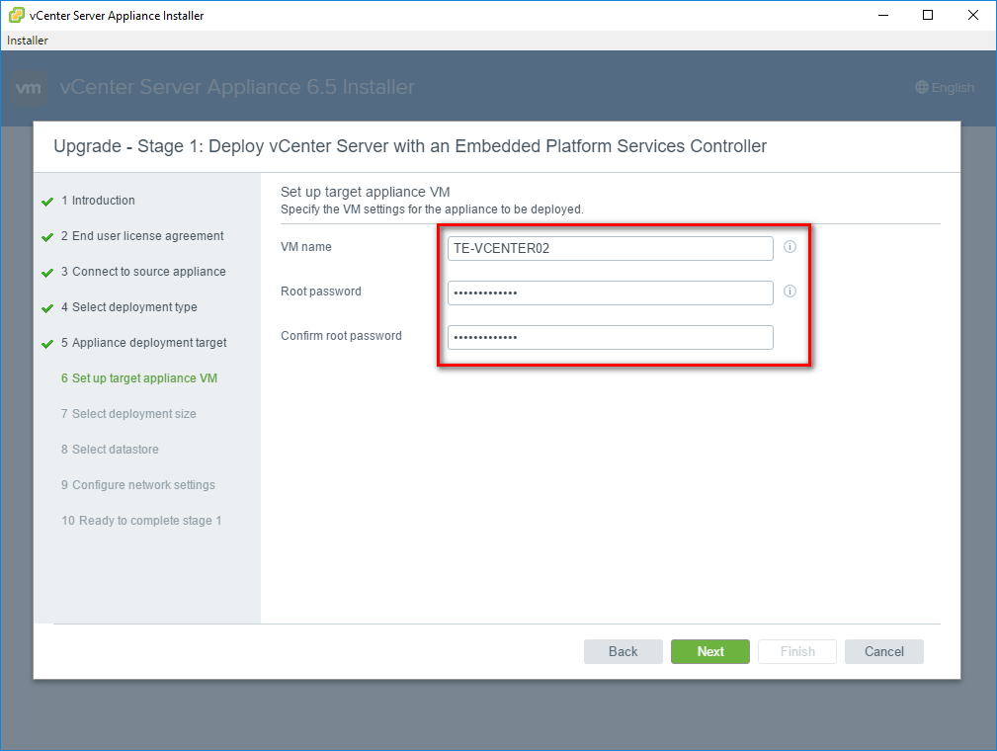

Choose your deployment size: Tiny

Storage Size: Default

If storage size only has the option Large or Xlarge, then the Vcenter wil have to be redeployed using the Vsphere install script:

* Remove ESX’s from vcenter
* Remove current vcenter
* Deploy new vcenter

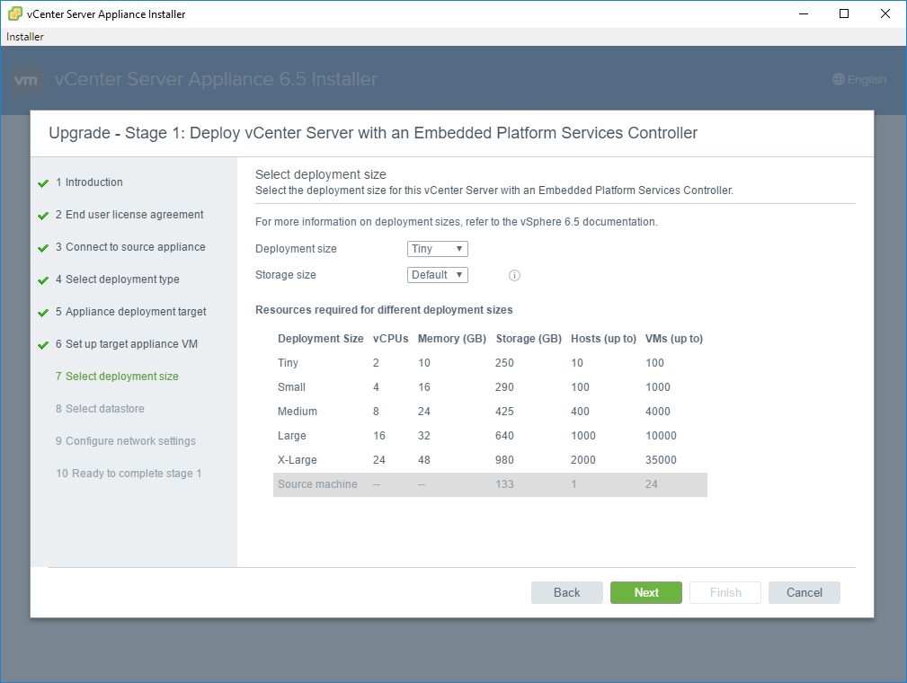

Select a datastore on which the new vCenter will reside according to its free space.

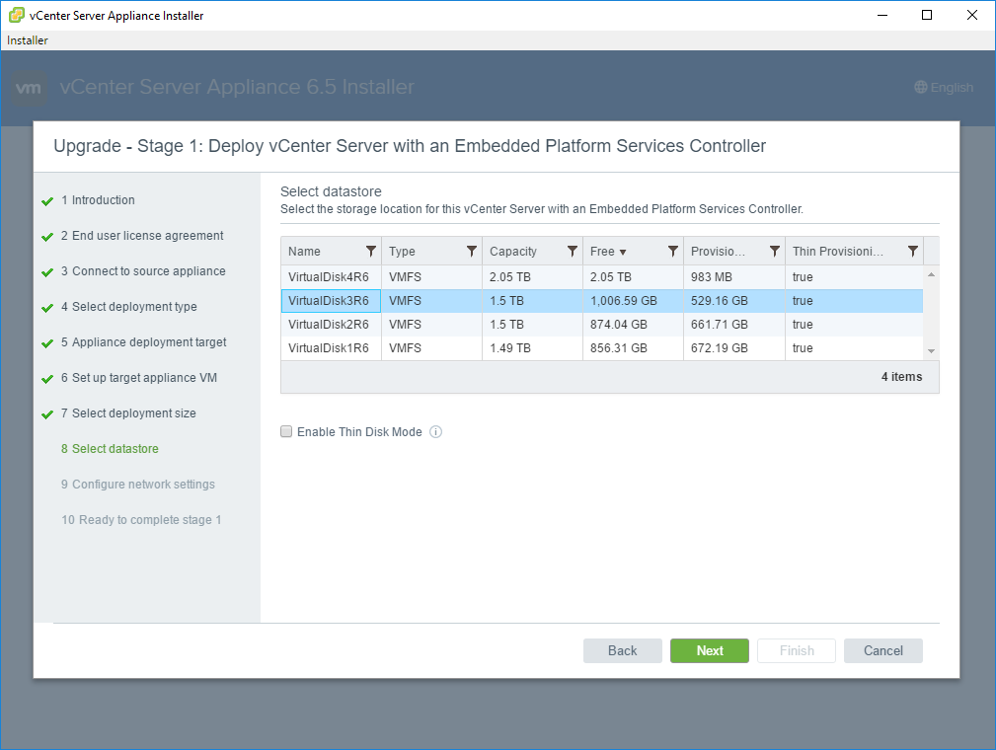

Pick the admin-trust port group and enter a temporary IP address the VCSA can use for the migration. It will only use this IP for the migration and will take over the IP address of the source Windows vCenter server.

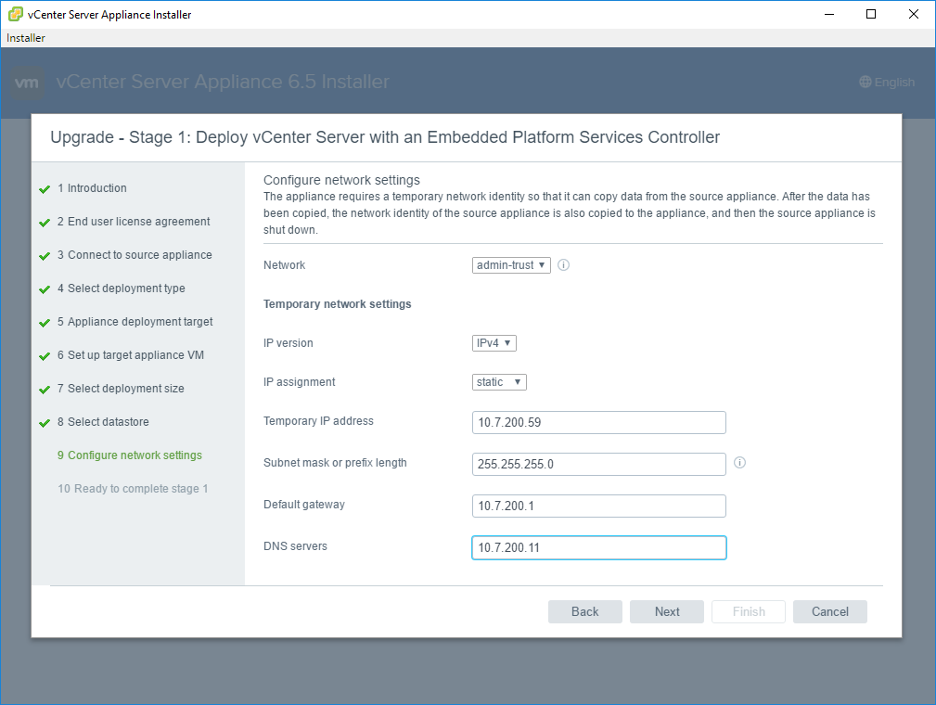

Confirm the settings

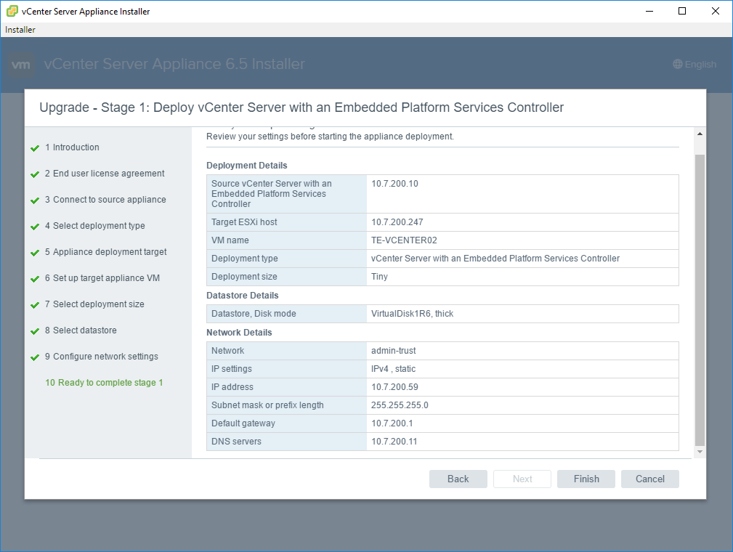

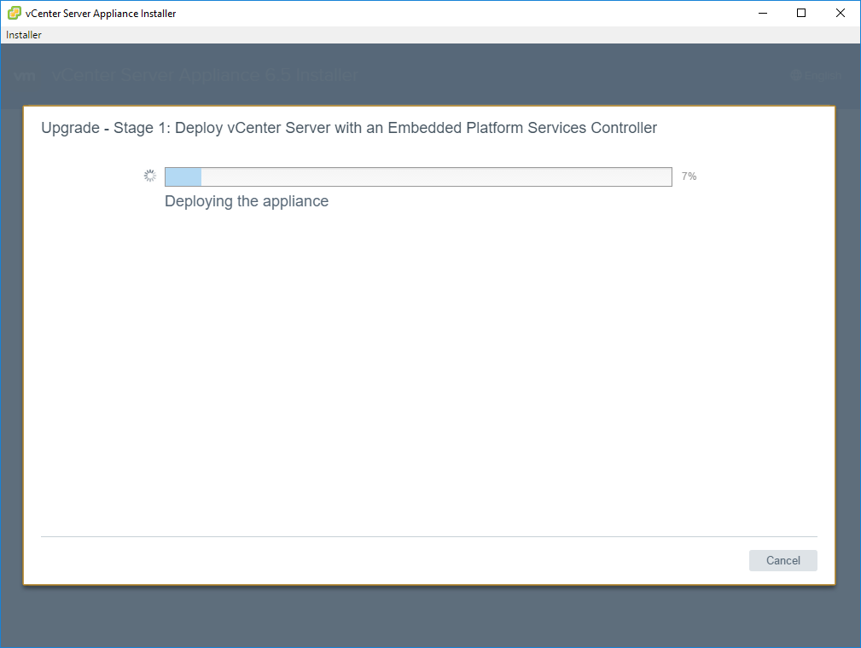

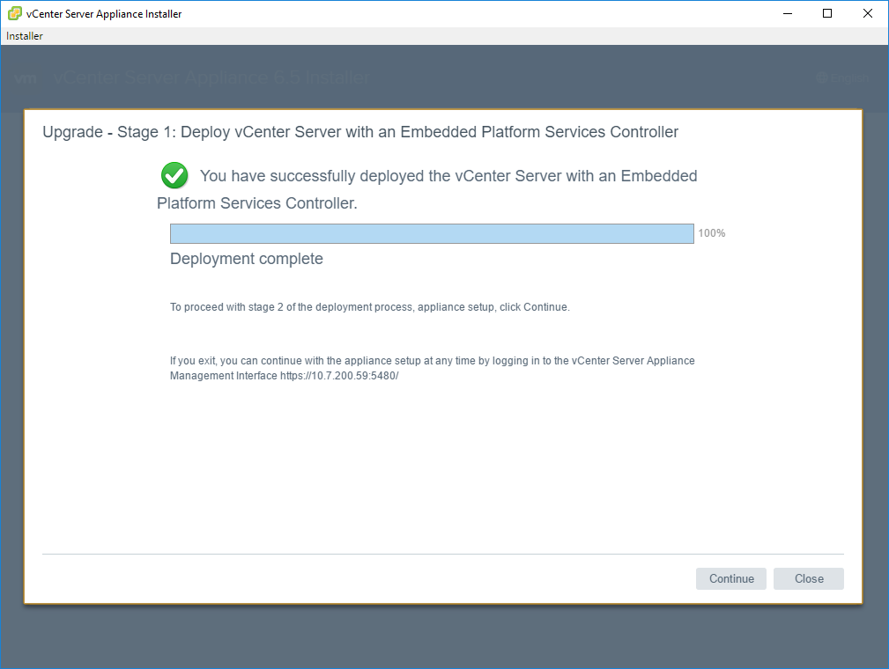

Now stage 2 of the vCenter deployment starts.

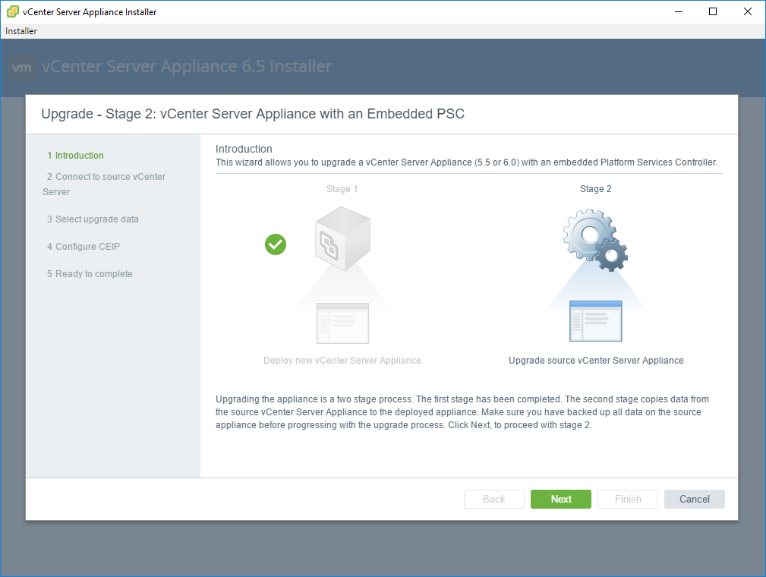

As we don’t use Automated DRS in our environment, simply click close and proceed the data migration.

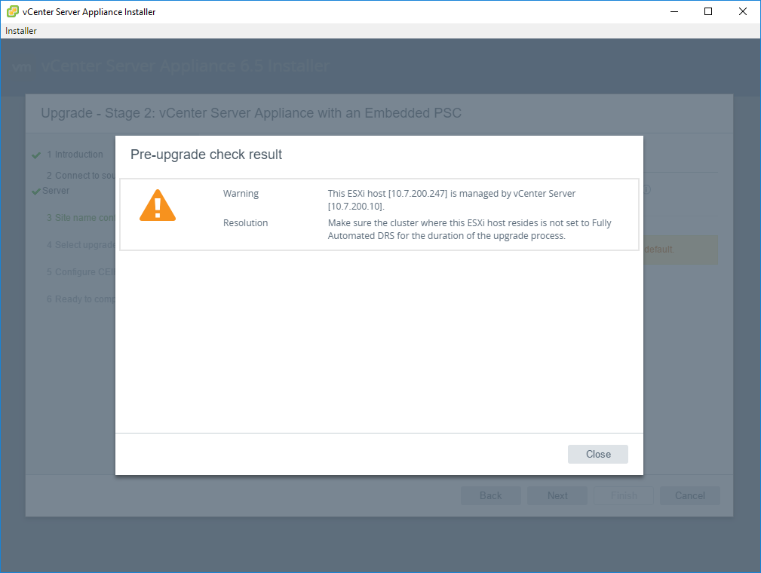

Enter your SSO site name

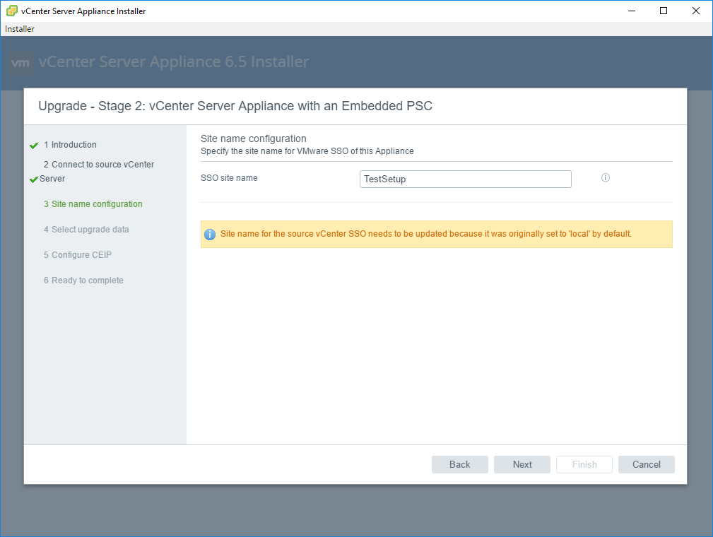

Always upgrade **ALL** data

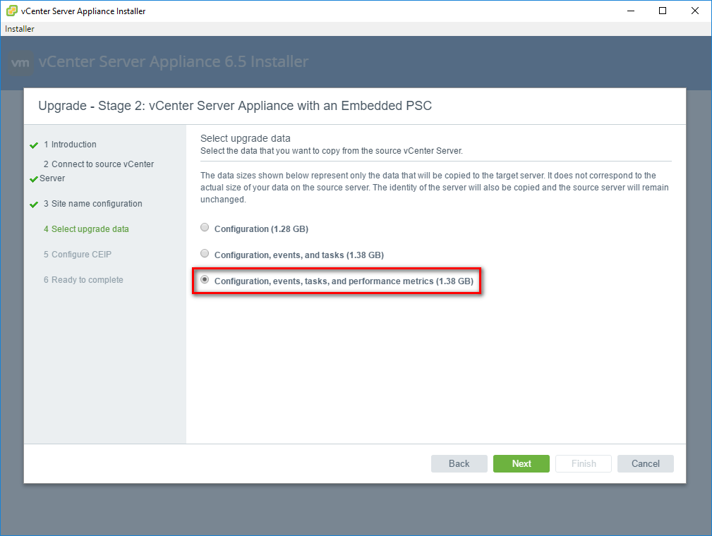

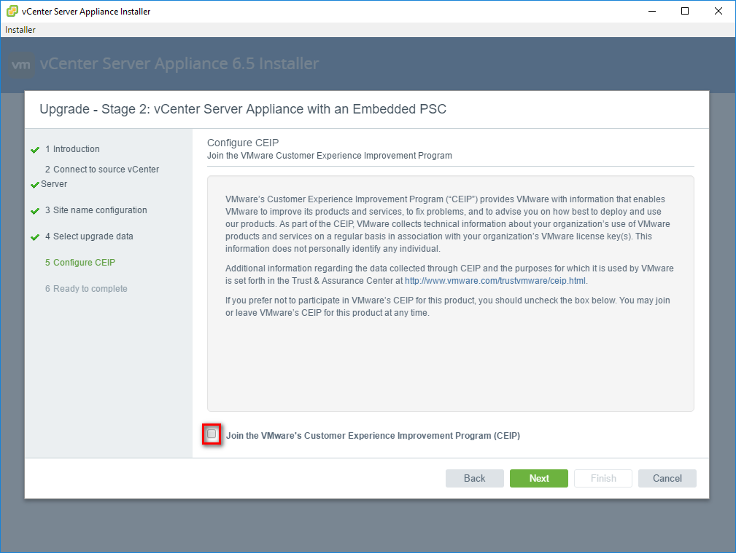

Assure that you have everything backed up and mark the checkbox

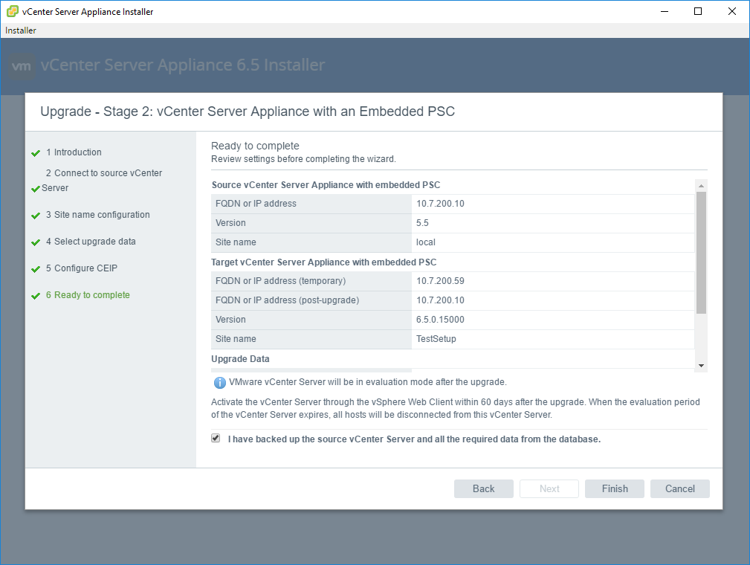

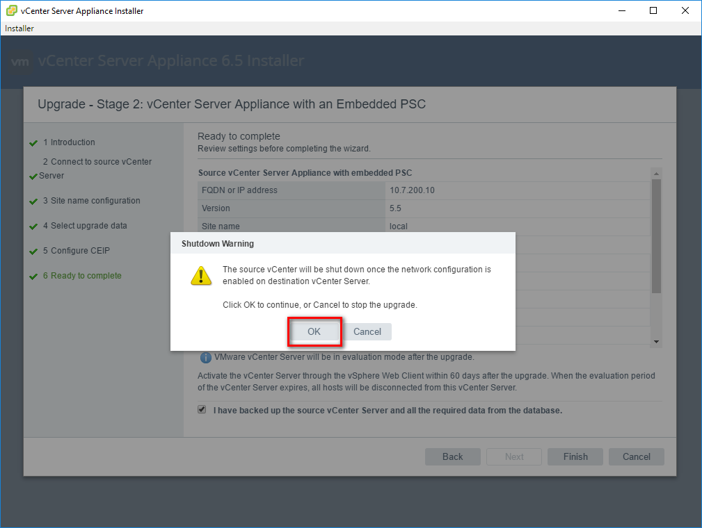

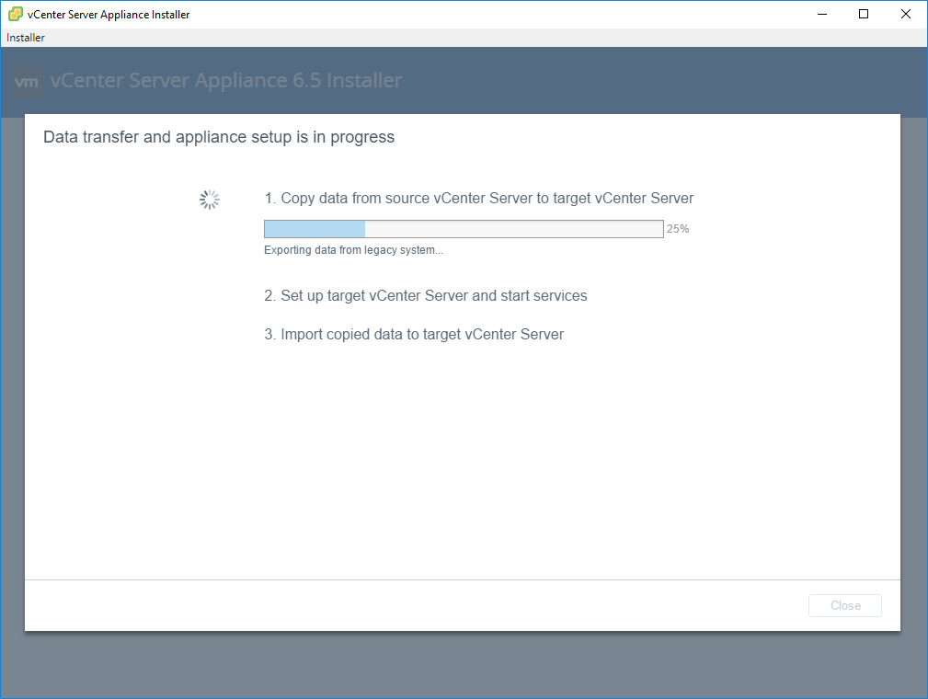

Once the wizard is complete, click the link to open the VCSA and verify the configuration.

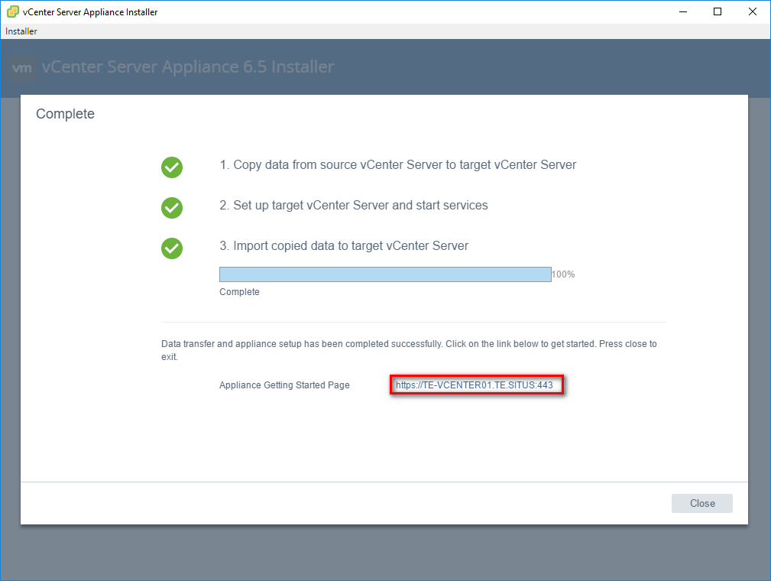

Because we named our new vCenter “XX-VCENTER02”, we want to create an alias to refer to the original IP address.

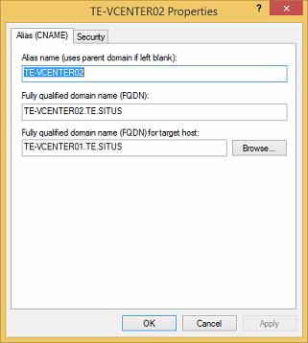

Check if you get a ping reply from the original VCSA if you ping to XX-VCENTER02 to verify your alias:

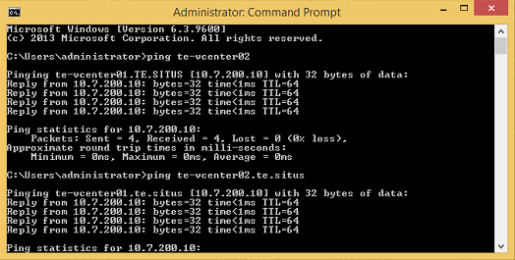

# Upgrade the ESXi hosts

Create a bootable stick with the ESXi software.

Perform a vMotion of all hosts that reside on the host you want to upgrade (if there is more than 1 host). From this moment you will have the first downtime! As we don’t have the license to perform a live vMotion, you will have to shut down all VMs on the host before vMotioning.   
Enter your host into maintenance mode.

Once your host is in maintenance mode, go to the CMC > Storage > Virtual Disks > Assign.

There you put all the VirtualDisks connected to the blade you are about to upgrate to “No Access”. Only from the blade you are about to upgrade.

If you do not do this, there is a chance that the upgraded blade will not see your Datastores any more after the blade reboot (and you will have a very bad time fixing this, think 24hour delay).

(if this does happen: move all data over from 1 datastore to another datastore and recreate the datastore, do this for all datastores)

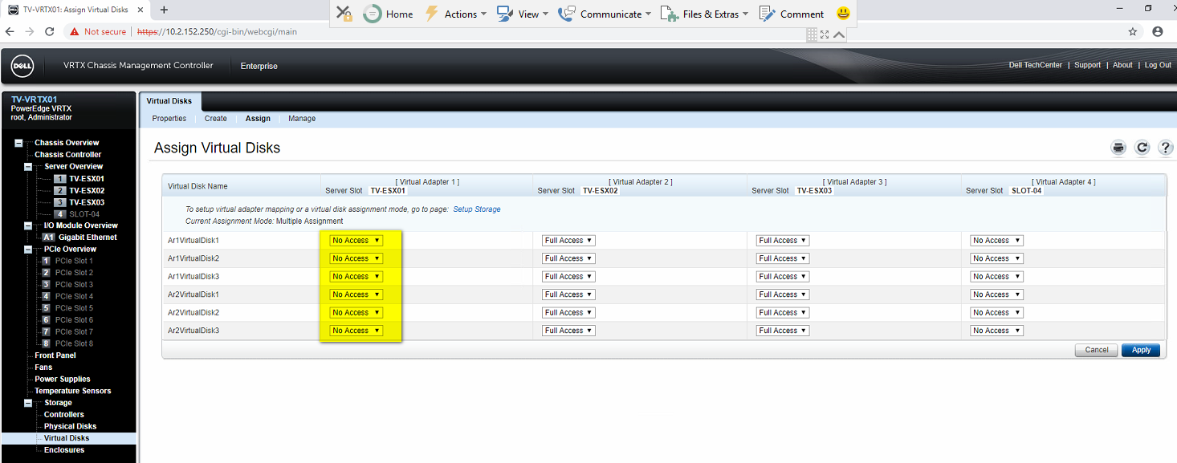

Start the ESXi installation on the host.

Once booted from the USB, select the installer in the boot menu selection.

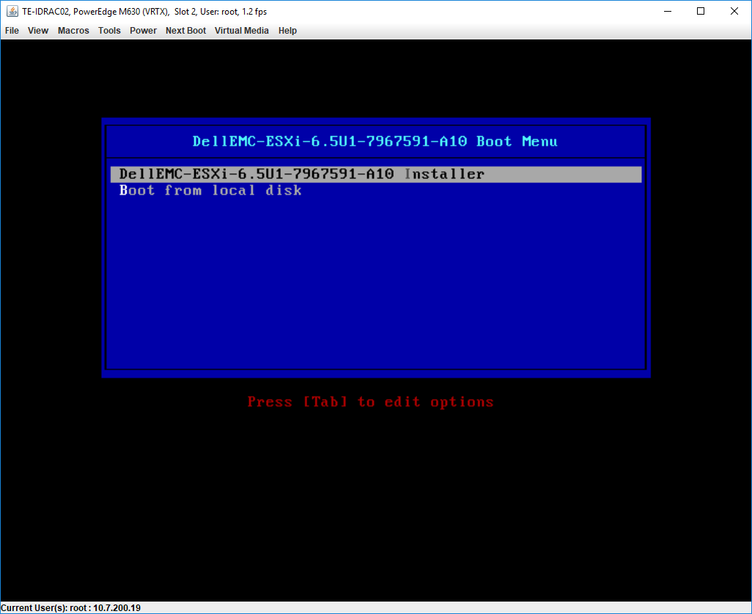

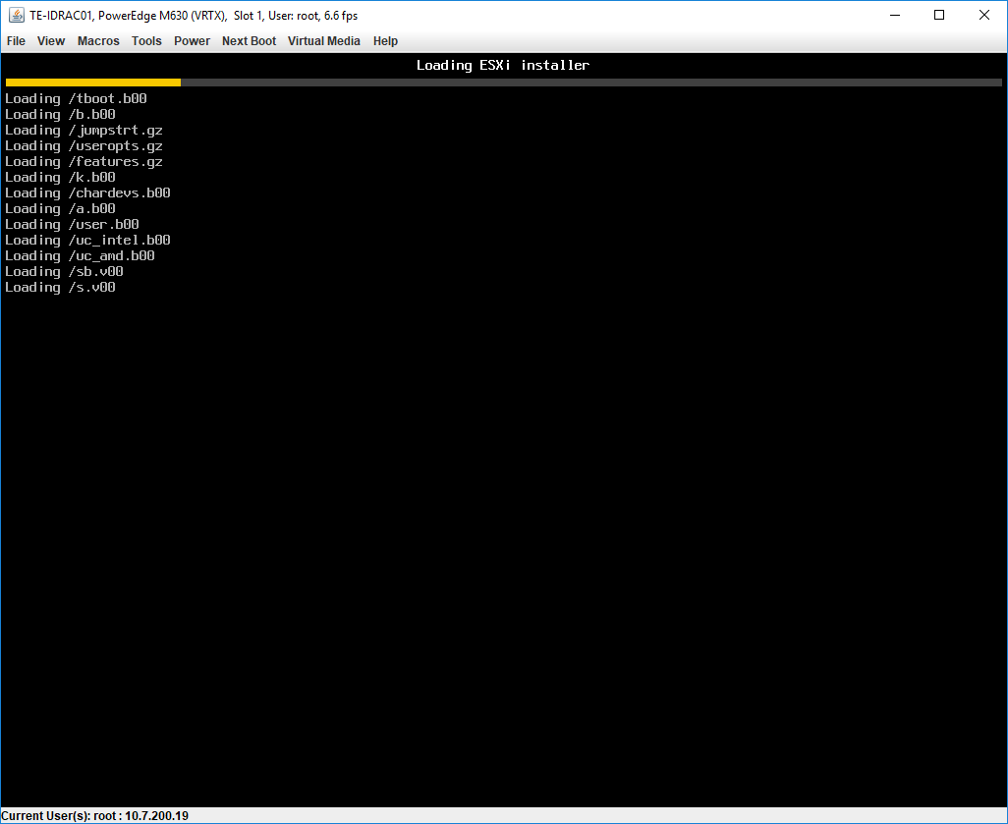

At the Welcome screen, press Enter to start.

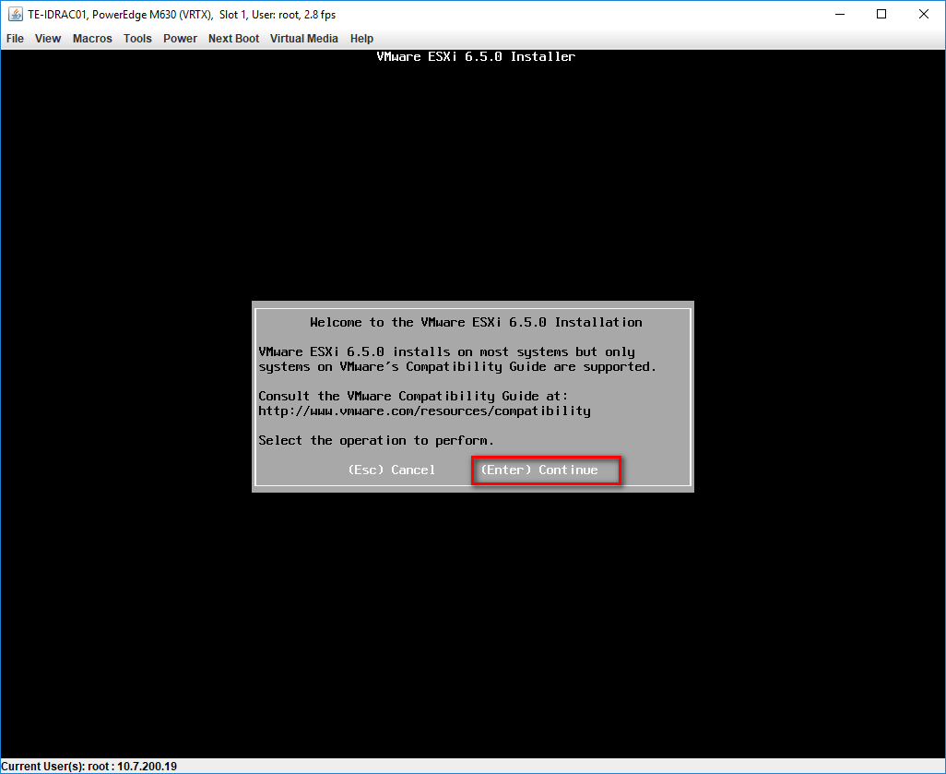

Accept the EULA.

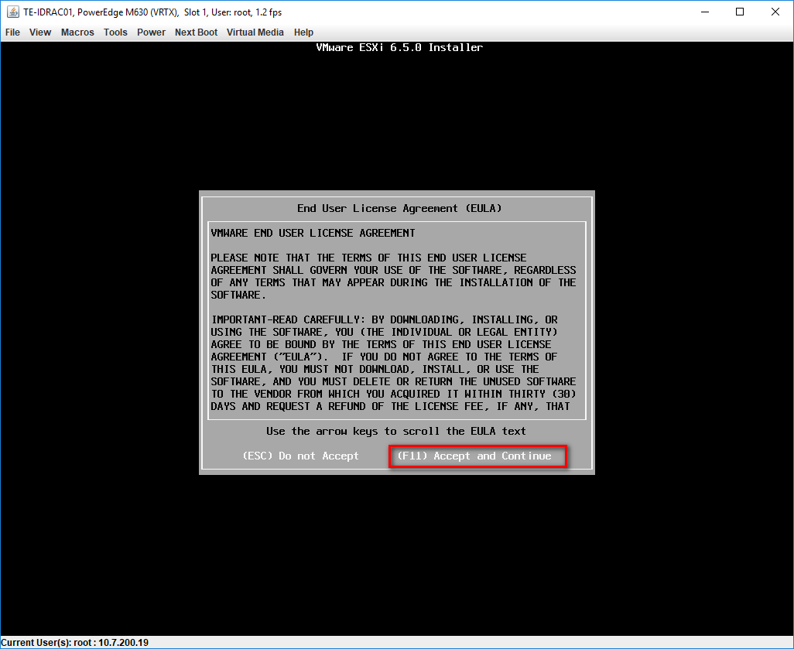

Choose a local Dell disk on which the upgrade will be installed.  
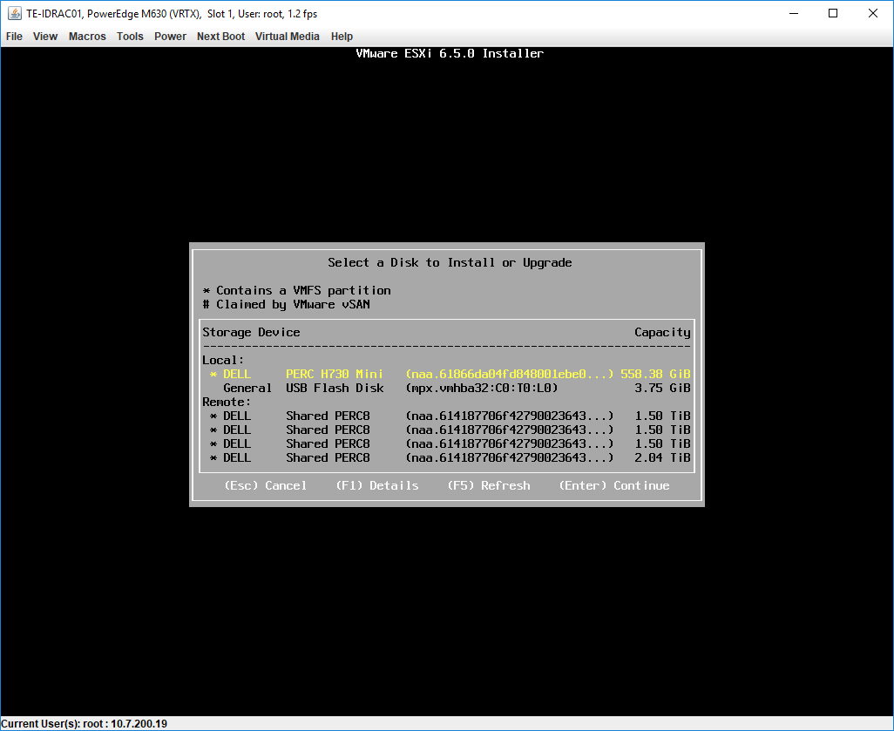

Choose Upgrade ESXi, preserve VMFS datastore.

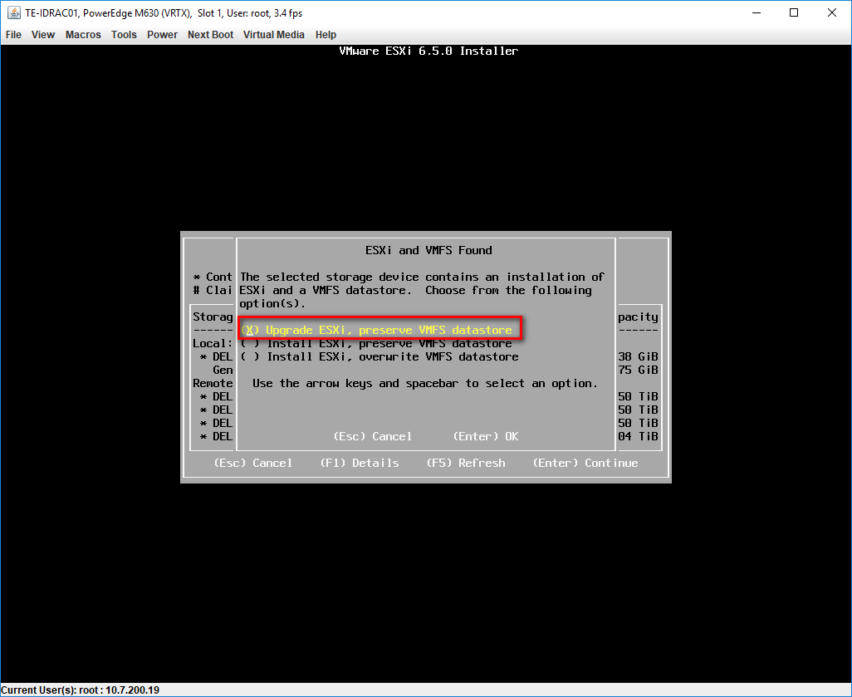

If the following error occurs then you need to manually remove a VIB first on the running ESX.

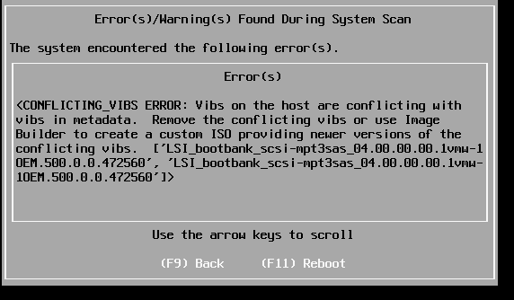

Reboot the ESX, connect using SSH and check the correct VIB name using command “esxcli software vib list”

After that use the following to remove the VIB:

“esxcli software vib remove --vibname=name”

After removing reboot the ESX then try to upgrade the ESX again.

Confirm the upgrade to ESXi 6.5 by pressing F11.

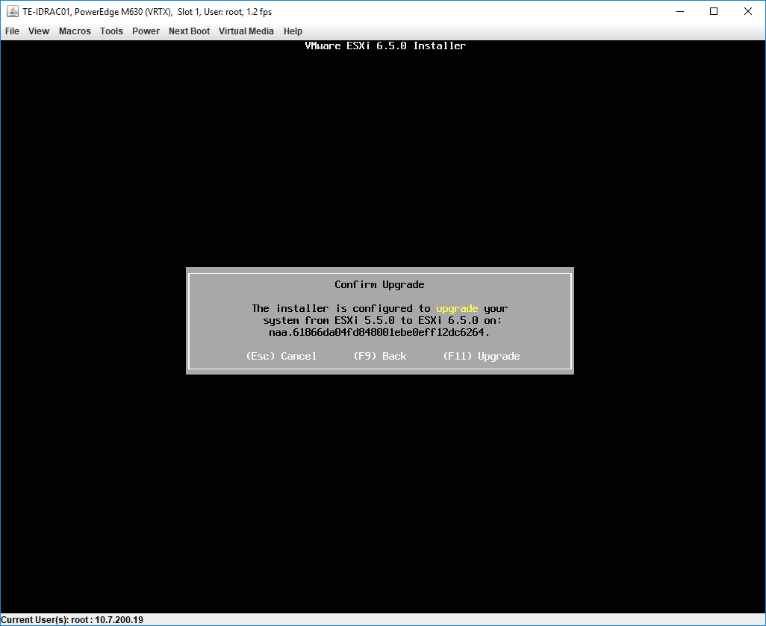

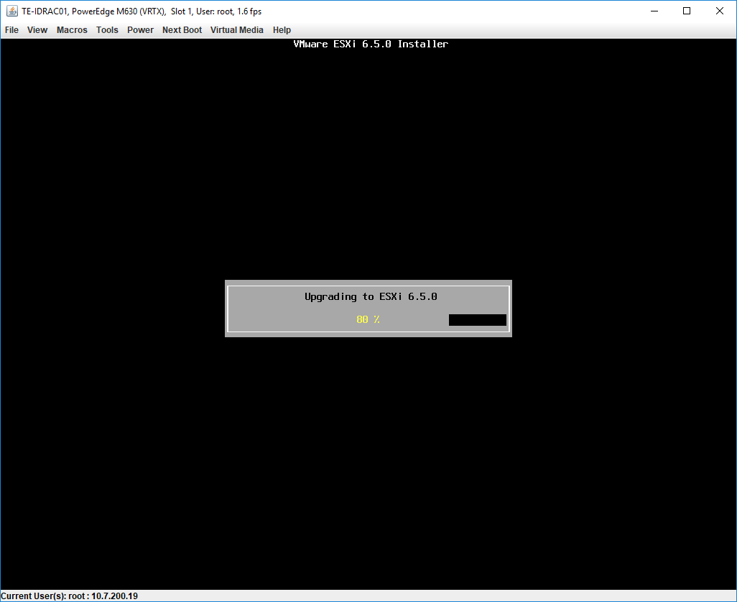

Remove your installation media and reboot the server

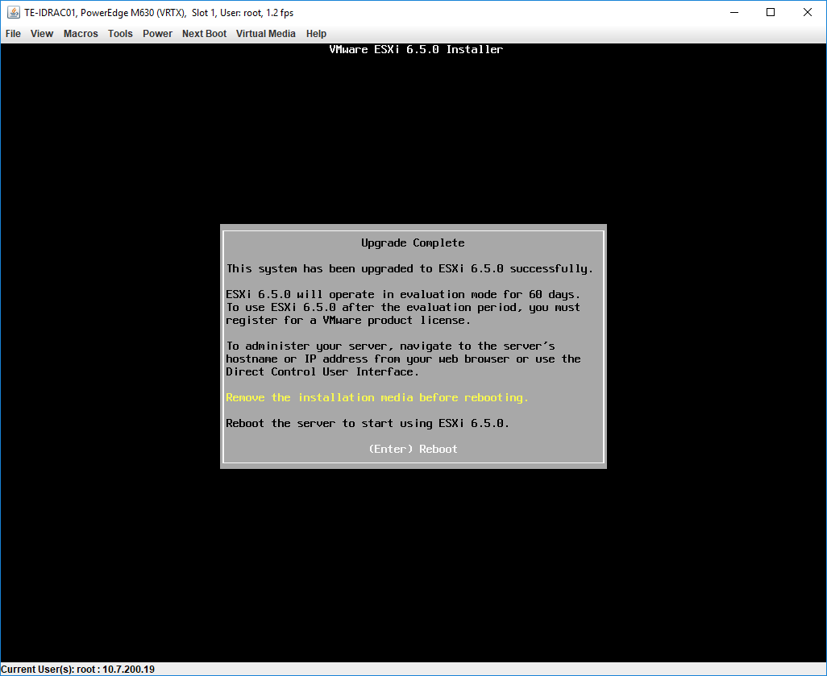

The upgrade process is now completed. Verify the ESX version.

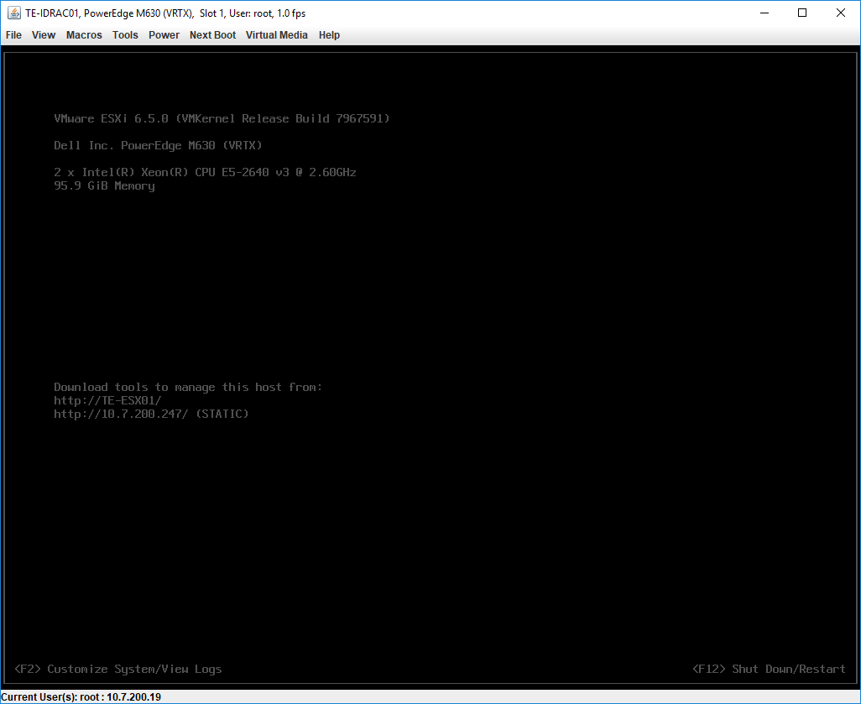

Reconnect all VirtualDisks in the CMC again.

Now login to the upgraded host, exit maintenance mode and vMotion all VMs to this host, as we have to upgrade the other hosts now.

Repeat this process for all hosts in the cluster.

# Upgrade VMs

Upgrade VMWare Tools on all Windows server and client VMs.

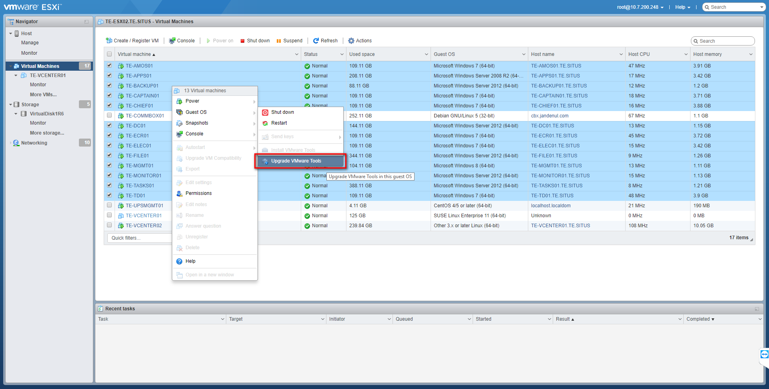

After you upgraded your vSphere cluster, it’s also important that all VMs are compatible to this new version. Check the compatibility of all VMs and upgrade this by right clicking the VM > Compability > Schedule VM Compatibility Upgrade...

This has to be done from the vCenter Server Appliance.

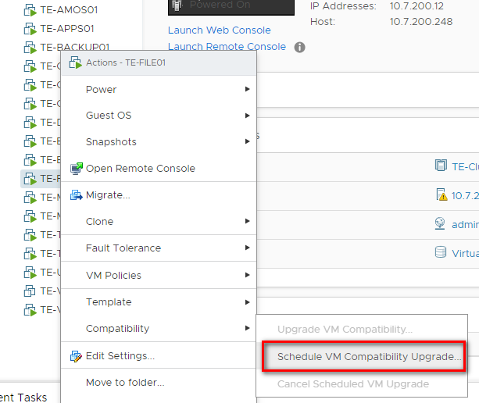

Once requested, choose compatible with ESXi 6.5 and later.

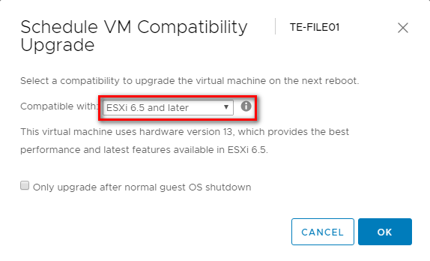

Modify the OS settings of all server and clients versions to the TO-BE OS version.

VMs need to be switched off in order to complete this.  
Right click the VM > Edit Settings .. > Tab VM Options > General Options

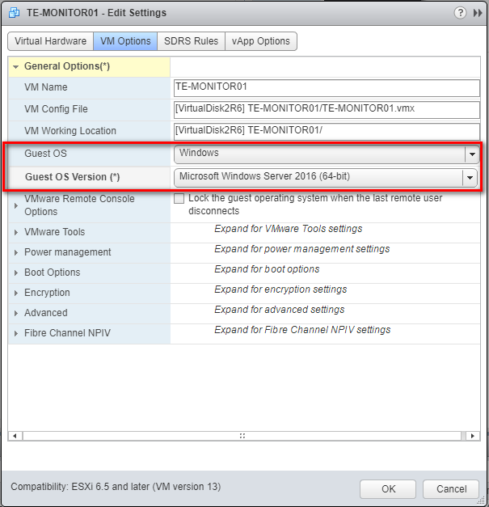

# Upgrade DC to Windows Server 2016

First we should start with our domain controller.

Make sure to upgrade the current Server 2012 DC to the GUI version.

Use powershell and the following command:

**Import-Module Dism   
Enable-WindowsOptionalFeature –online -Featurename ServerCore-FullServer,Server-Gui-Shell,Server-Gui-Mgmt**

Login to your DC and navigate to the setup.exe of your Windows Server 2016 ISO file, as you have connected its “CD/DVD drive 1” with the Windows Server 2016 ISO file. This file should be uploaded to the first datastore under the dedicated ISO folder.

Perform a forestprep, adprep and gpprep before upgrade the OS version.

Run the following commands in this order to do so:

* Adprep /forestprep
* Adprep /domainprep
* Adprep /domainprep /gpprep
* Schema version must be **87**

(Adprep can be run from the 2016 windows ISO, DVD\support\adprep\adprep.exe)

Run in your CMD the follwing command to start the setup:

**setup** **/compat IgnoreWarning**

Once started, select “Not right now” in the updates windows.

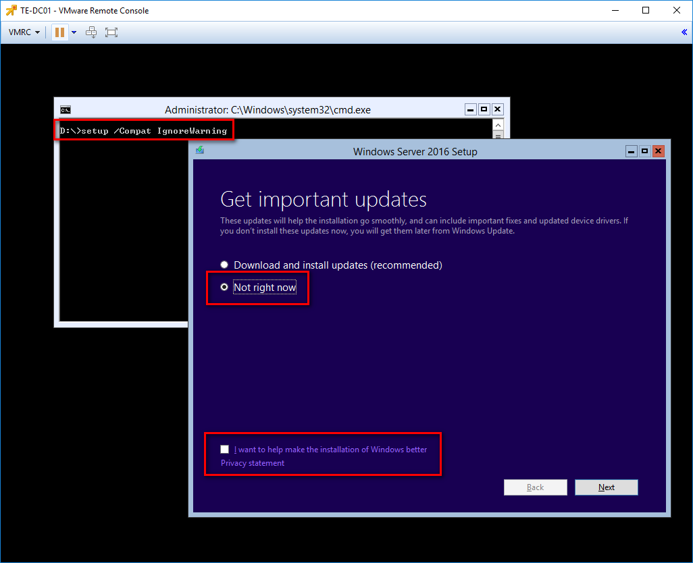

The setup will check your PC requirements.

In the OS selection window, choose:

* Windows Server 2016 Standard (Desktop Experience) for all **server VMs**

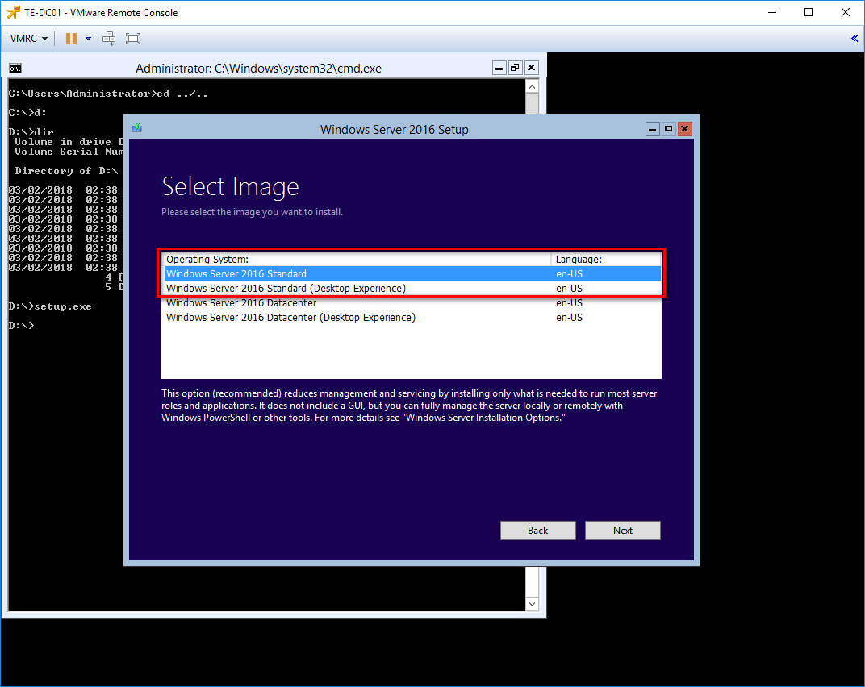

Accept the notices and terms.

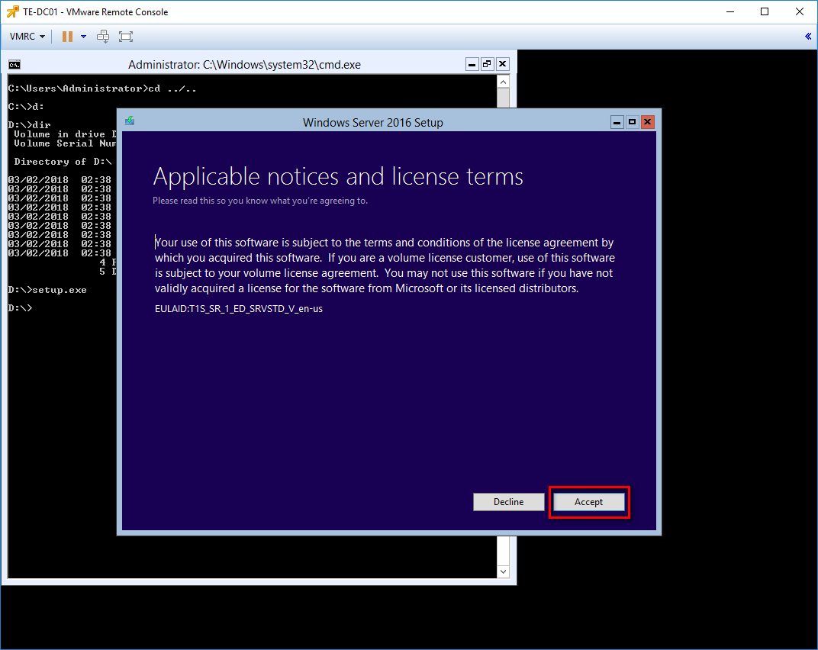

Choose Keep personal files and apps.

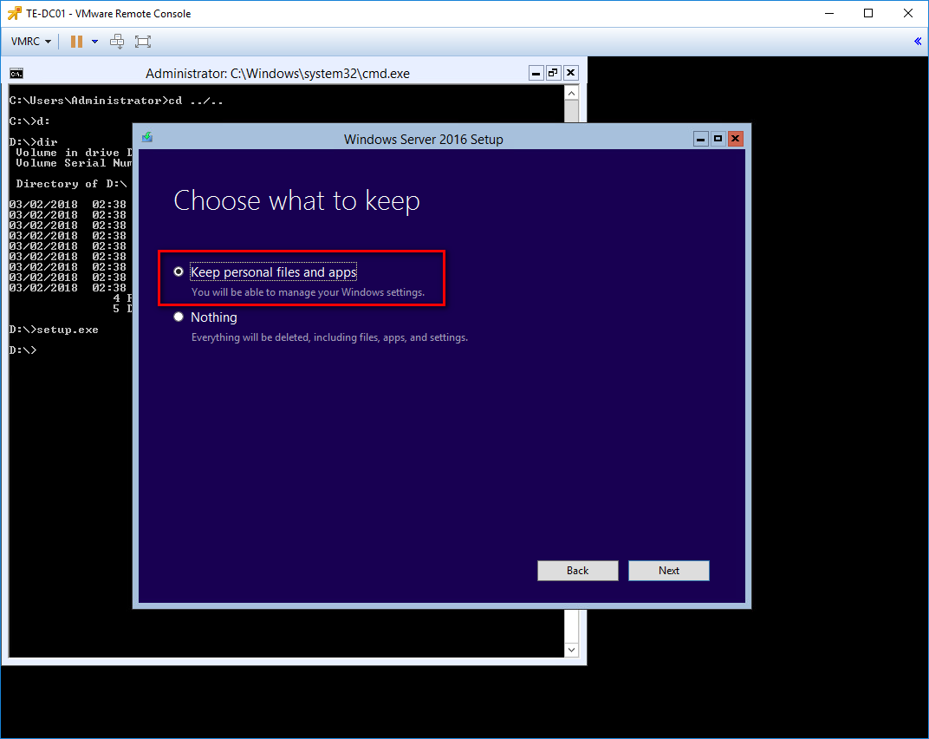

The setup will now perform a check before the upgrade process start. This can take a while...

Once requested choose Install to install the upgrade.

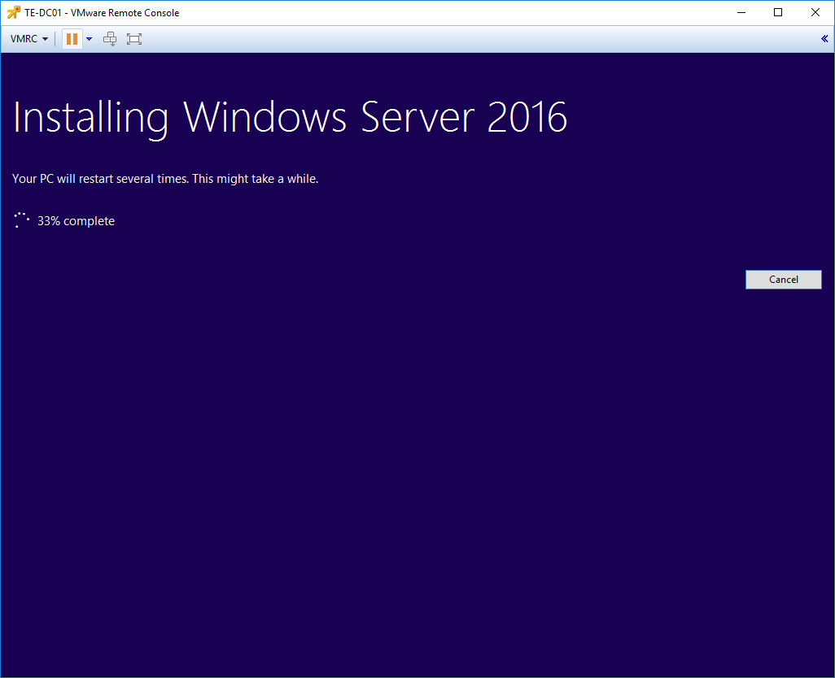

# Upgrade Server VMs to Windows Server 2016

Follow the steps as above for all server VMs in your cluster. Except that we don’t need CMD for starting the setup. Here we double-click the mounted ISO and run the setup.

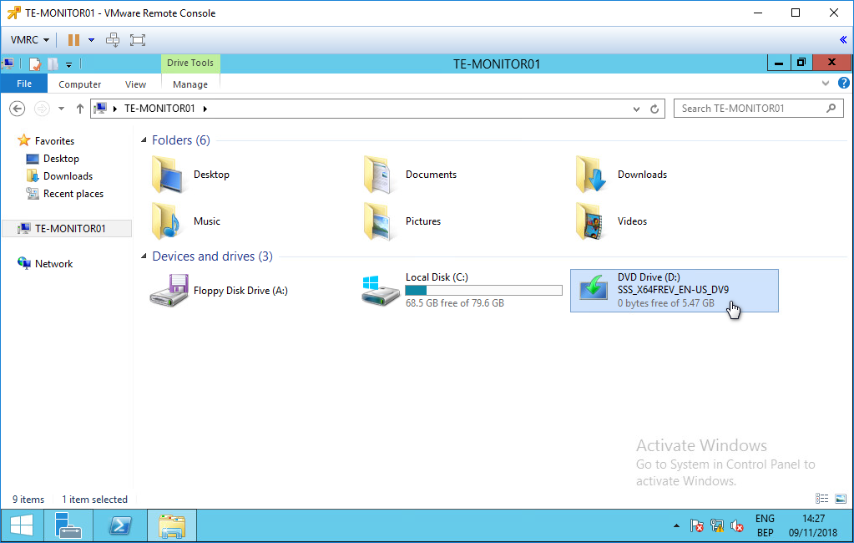

Click Confirm when requested. Upgrades are in fact not recommended.

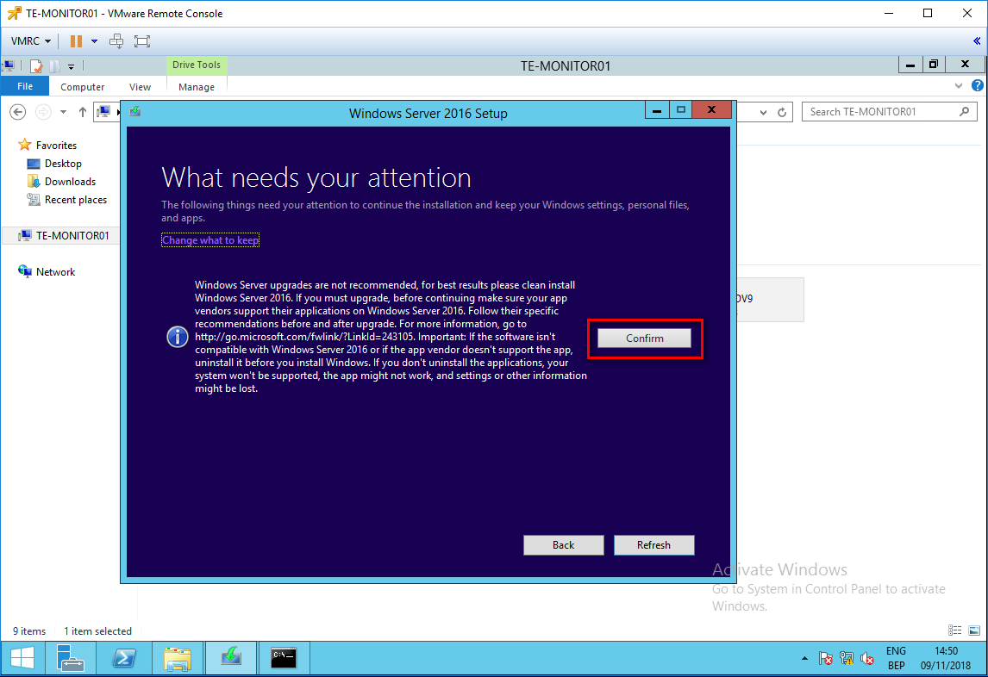

After this script ran, run the following powershell commands on the server VMs to add the Standards1.2 values to the register. This is for reporting purposes.

if(-not (Test-path "HKLM:\Software\JDN"))

{

New-item -Path "HKLM:\Software" -Name "JDN"

}

if(-not (Test-path "HKLM:\Software\JDN\Standard"))

{

New-item -Path "HKLM:\Software\JDN" -Name "Standard"

}

New-ItemProperty -Path "HKLM:\Software\JDN\Standard" -Name "Version" -Value "1.2.0" -Force -ErrorAction SilentlyContinue

New-ItemProperty -Path "HKLM:\Software\JDN\Standard" -Name "Build" -Value (Get-Date).ToString("ddMMyyyy") -Force -ErrorAction SilentlyContinue

New-ItemProperty -Path "HKLM:\Software\JDN\Standard" -Name "Timestamp" -Value (Get-Date).ToString("dd/MM/yyyy") -Force -ErrorAction SilentlyContinue

Change standard version (1.2.0, ….) if applicable.

< I will create a .ps1 script for this in the future >

# Create new Win 10 Clients VM’s

The client VMs will not be in place upgraded.

Create new win 10 client VM’s using the Win10 OVA Template.

The naming convention will be XX-USER(n+1).  
For example if the existing Win7 VM is CD-CAPTAIN01, then the new Win10 VM will be CD-CAPTAIN02. If you have CD-ELEC01, CD-ELEC02 and CD-ELEC03 running, then the Win10 VMs will be CD-ELEC04, CD-ELEC05 and CD-ELEC06.

There is one exception! For the Training VM we should always use the name XX-TRAIN01!

Compare the printers and software installed on the Win7 VM, migrate all data and apply the amos number.

Change the RDP connection on the FAT client to the new VM.

In the end, remove the old Win7 VM from your vSphere environment.

# Raise FFL and DFL

Once the MGMT VM is upgraded, raise first your FFL and then the DFL to Windows Server 2016.  
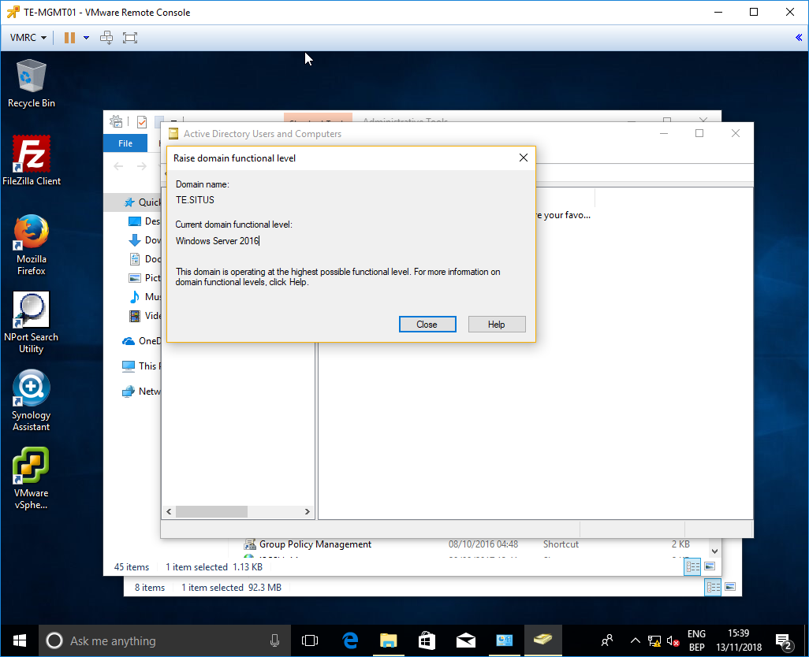

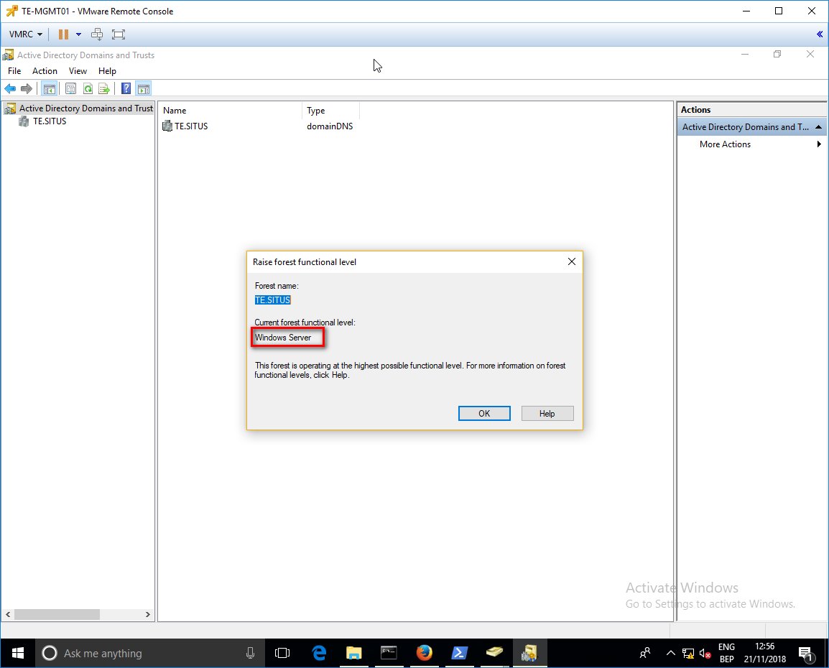

Don’t forget to disable root password expiration.

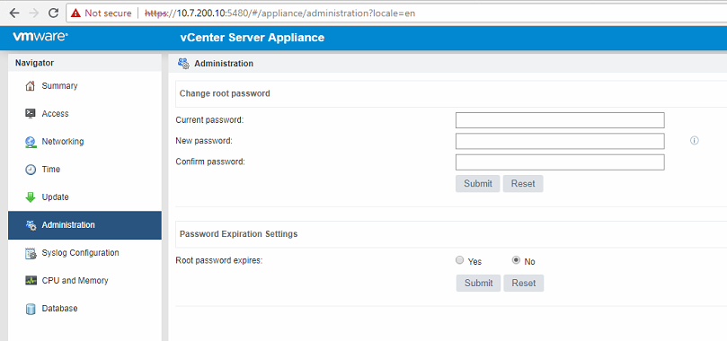

# Upgrade Applications

Now upgrade the following applications:

* Veeam 8.0 to 9.5
  + After updating Veeam enable the following on existing backup jobs
    - Exclude Deleted files. Located in the properties of the job.
    - Create new backup job for the File server if not already so.
* Check PRTG and replace old sensors

# Commbox

- Change connection priority to the same of the FW to have correct reporting

- Change IP settings if junipers have been replaced by Fortinets.

# Pihole

Deploy or update to latest Pihole version

* Best to update using 3G connection

# Licensing

(Do this at the last moment, storage Vmotion is possible using the trail licenses. Not with the JDN licenses)

Now we need to add the licenses for vSphere 6.5. First we’ll start for the vCenter installation. Login to your vCenter, where you will see the popup that your licenses are expired. Click Manage your licenses.

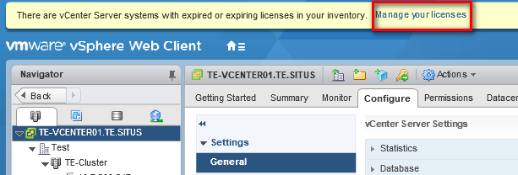

Add the new license.

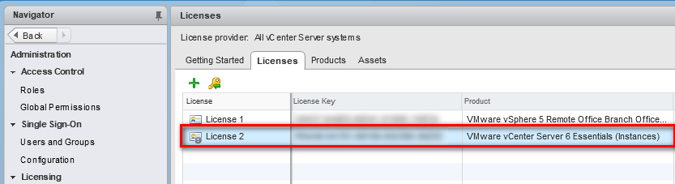

Assign the license to the new vCenter by clicking the tab Assets.

Now perform the same steps to add the new license for the ESXi hosts.

# Troubleshooting

## iCat doesn’t work

* + Check IP of the APPS server. For a yet unknown reason, the APPS server received a DHCP Lease. This needed to be set again to a fixed IP X.X.X.14.

## Veeam

* If current version is 8.0 no update you first need to update to 8 update 3 before you can update to the latest 9.5
* After Veeam upgrade to Version 9.5 – 3A, you receive the message that there is a newer update needed for the vSphere version. (Until further notice, do NOT use update 4a)

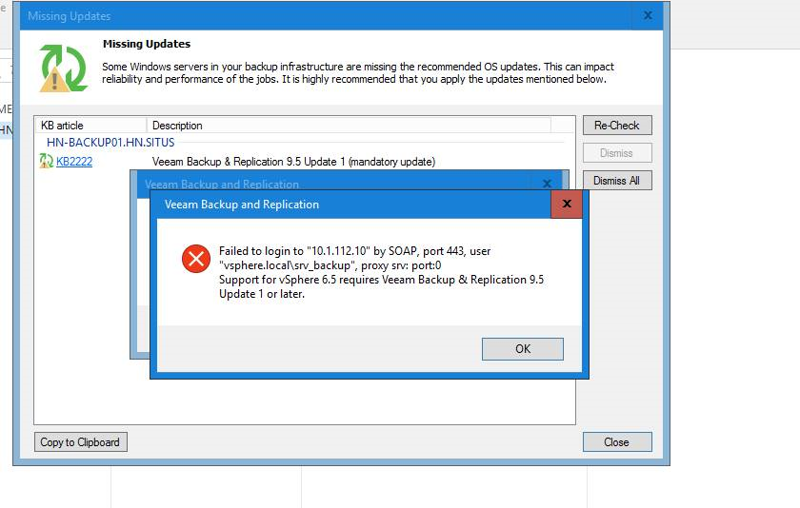

* + Restart the installer and choose repair and afterwards choose install.

## iRep doesn’t work

* + Verify that the following Windows Services are running with startup type “Automatic (Delayed start)”.

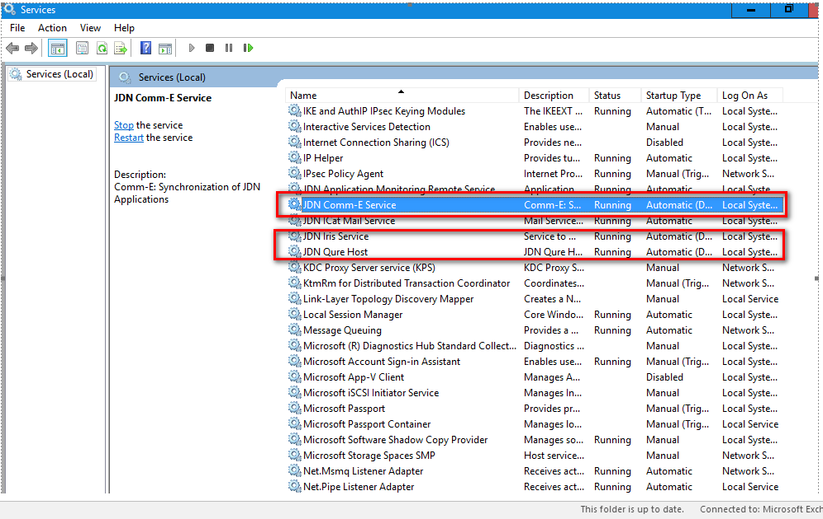

## Dell Storage Driver Error bij upgrade Windows Server OS of the task server

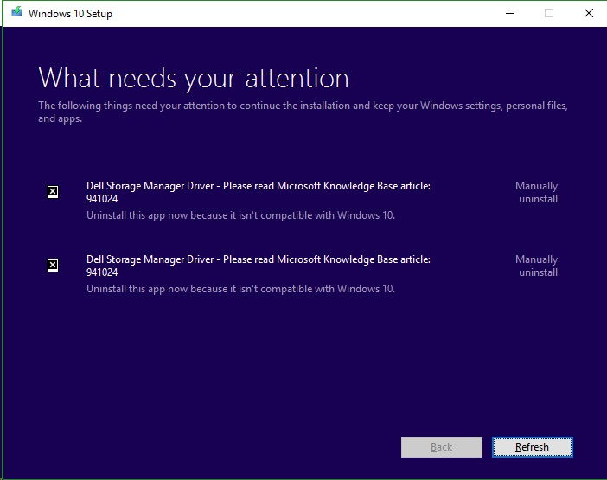

To Fix :

Open command line Diskpart

Remove Letter=E

Na update

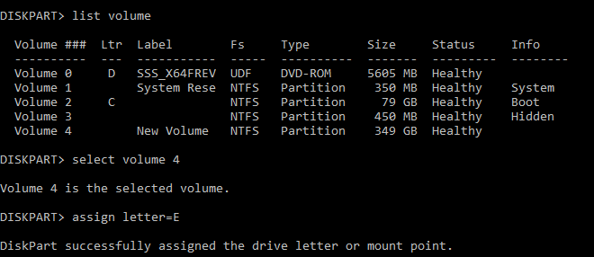

## Win10 Jump

Indien Jump 2 Win 10 al na enkele seconden na het instellen van de keyboard layout en computernaam, weergeeft dat de usb moet verwijderd worden, volgende stappen uitvoeren (Voorval op Taccola bij HP ProDesk 600 G1)

* Herstart PC en ga naar bios settings.
* Verander bij security:
  + Secure boot --> disabled
  + Legacy boot --> enabled
* Herstart pc
* Selecteer USB drive in legacy mode
* Unplug aangeduide connectors van moederbord:  
  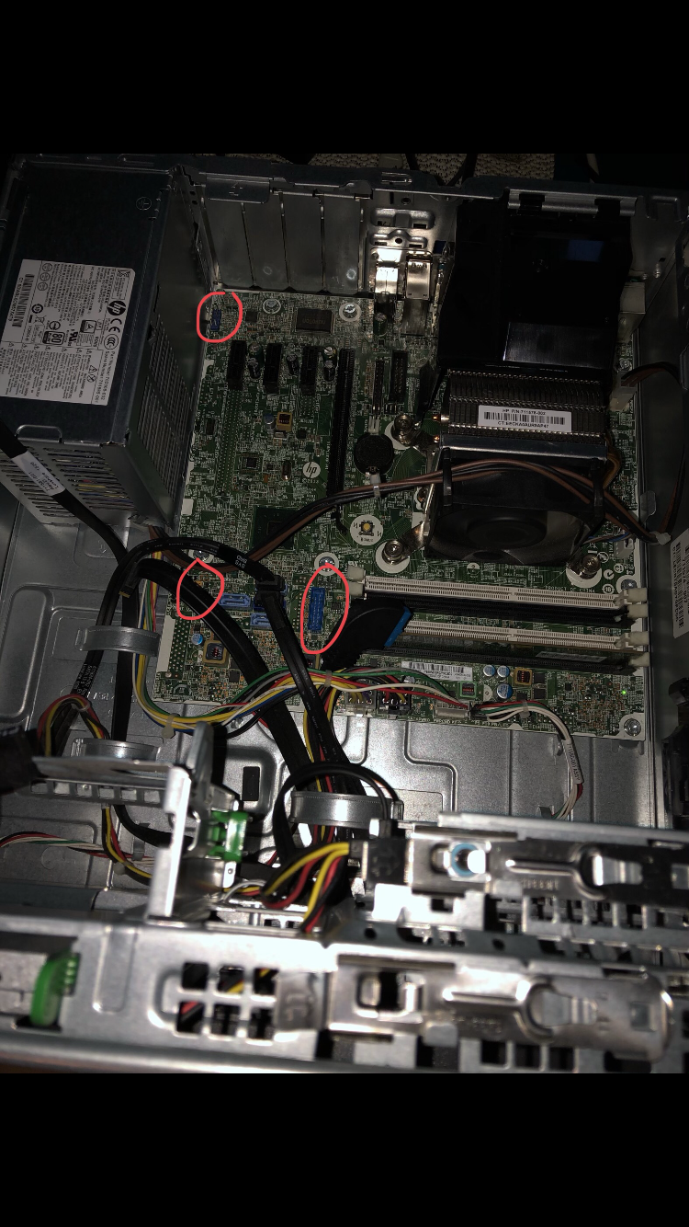
* Kies keyboard layout
* Voer indien gevraagd JDN-(+nummer) in als computernaam
* Controleer of procedure verder loopt
* Zodra de voortgang getoond wordt van het deployen van de image, is alles in orde normaal
* Zodra de melding verschijnt dat de USB verwijderd moet worden:
  + Connectors terug verbinden
  + USB verwijderen
  + Press any key

## UPS

APC firmware update using APC console cable, normal console cable is not compatible

## Wifi

Update latest firmware and add Certificate in case of issues

## WR44

If WR44 is slow update to the latest FW version using the “update firmware” page and upload the .zip file found using the link on the “update firmware” page.

## Radio holland

Check if Server radio holland has a Idrac port in case it is not reachable on the idrac IP.

## Printers

Check if Stock settings are correct and set as default after update to 2016

## Outlook

Enable Spel checking NL and ENG

Copy autocomplete file to the new VM to get the of contacts in the autocomplete list.

## Excel

Enable Macro’s and VBA scripting in excel if there are errors in excel forms the ship uses.